Before the Flood presentation

Introduction:

### 1/ In which year can we sail through the North Pole ?

2020

**2040**

2075

2100

Picture:

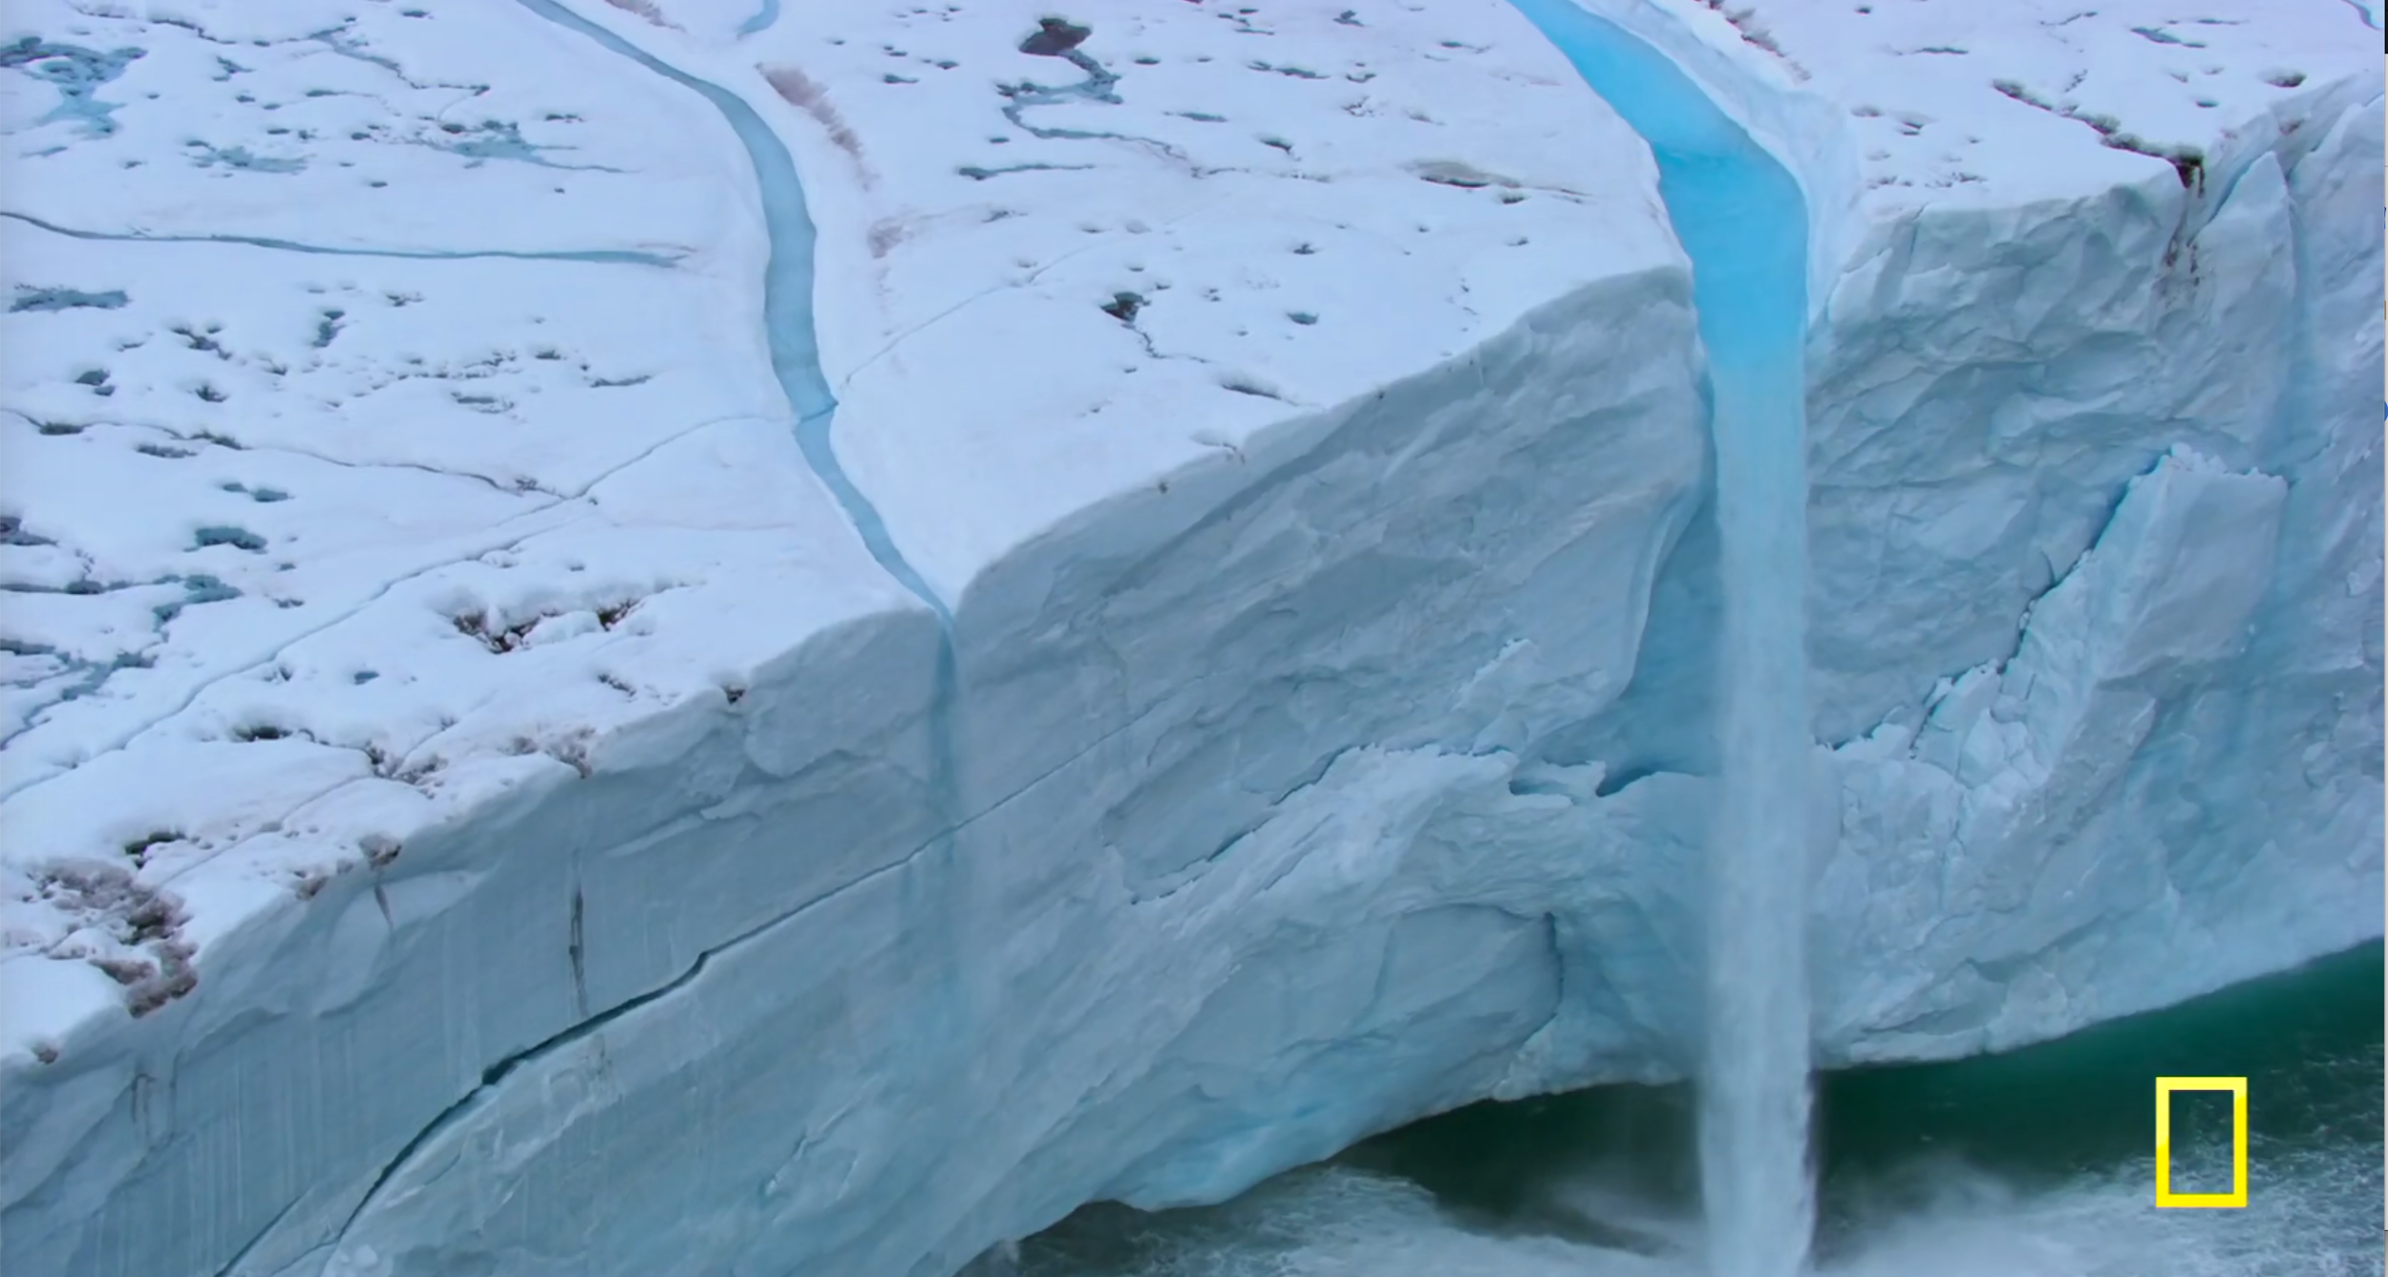

In the last years the ice quality in the baffin island, Canada has changed. It used to be clearer and solid. Now it has the same size but melts faster.

It acts as the air conditioning of the world.

It is disappearing, it changes currents and air patterns.

Small personal changes used to be thought as the way to go to fight the climate change. Now we know that it is not enough

Projections for future are conservative. It nothing changes compare to last decade, no more greenland. 100 km^3 of ice melted over all the surface of greenland.

Goes into the sea -> sea level rise

### 2/ methode d’extraction

Between theses forms which is the most devastating form of producing fossil fuels

A- Mountain-top removal for coal

B- Fracking for natural gas

C-Offshore drilling for oil

D-Tar sands

Reponse: Tar sands. They take away massive forests, the water in the streams and rivers is poisoned. It has severe impacts on wildlife and it requires a huge amount of energy simply to get it our fuel tanks.

We are knowingly decimating the ecosysteme forever, much larger scale than before !

If we’re gonna fight climate change effectively, we have to start by acknowledging that most of our economy is based on fossil fuels.

Oil -> powers most of the transportation sector

Coal + natural gas -> power most of the electricity

### 3/ Miami

Sunny day flooding, back flowing from drains

Pumps across the city + raise roads

### This changes will have an impact for how many years ?

10-20

**40-50**

100-150

200-300

Picture:

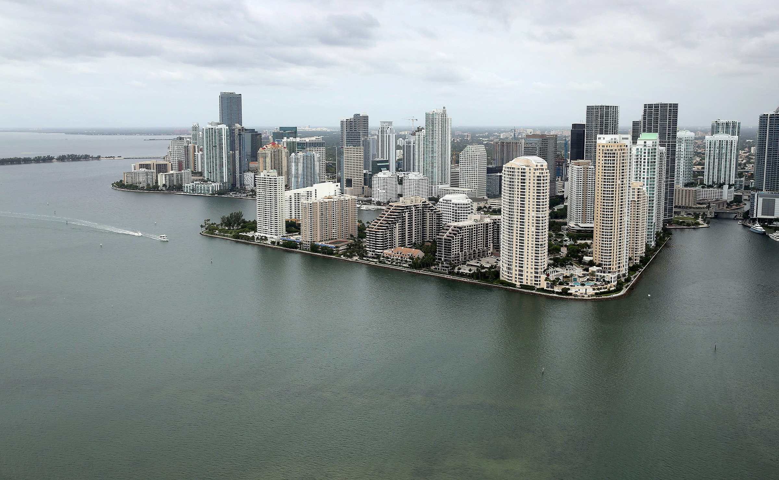

400 million $ project

New solutions but deniers

The ocean is not republican and not democrat

### 4/ How many electricity does an American consume at home?

10xCitizen of China

34xCitizen of India

7xcitizen of France

10xCitizen of Japan

1 américain

==> 1.5 fr

==> 2.2 jp & uk

==> 2.6 Germany

==> 5 South Africa

==> 10 China

==> 34 India

==> 61 Nigeria

construisent + gd & +

==> utilisation de + de ressources avant

question du mode de vie et de consommation au centre du changement climatique

--> américains veulent pas entendre

Trump +

### 5/ What is the percentage of burned forest by companies in Sumatra, Indonesia ?

20%

40%

60%

**80%**

Picture:

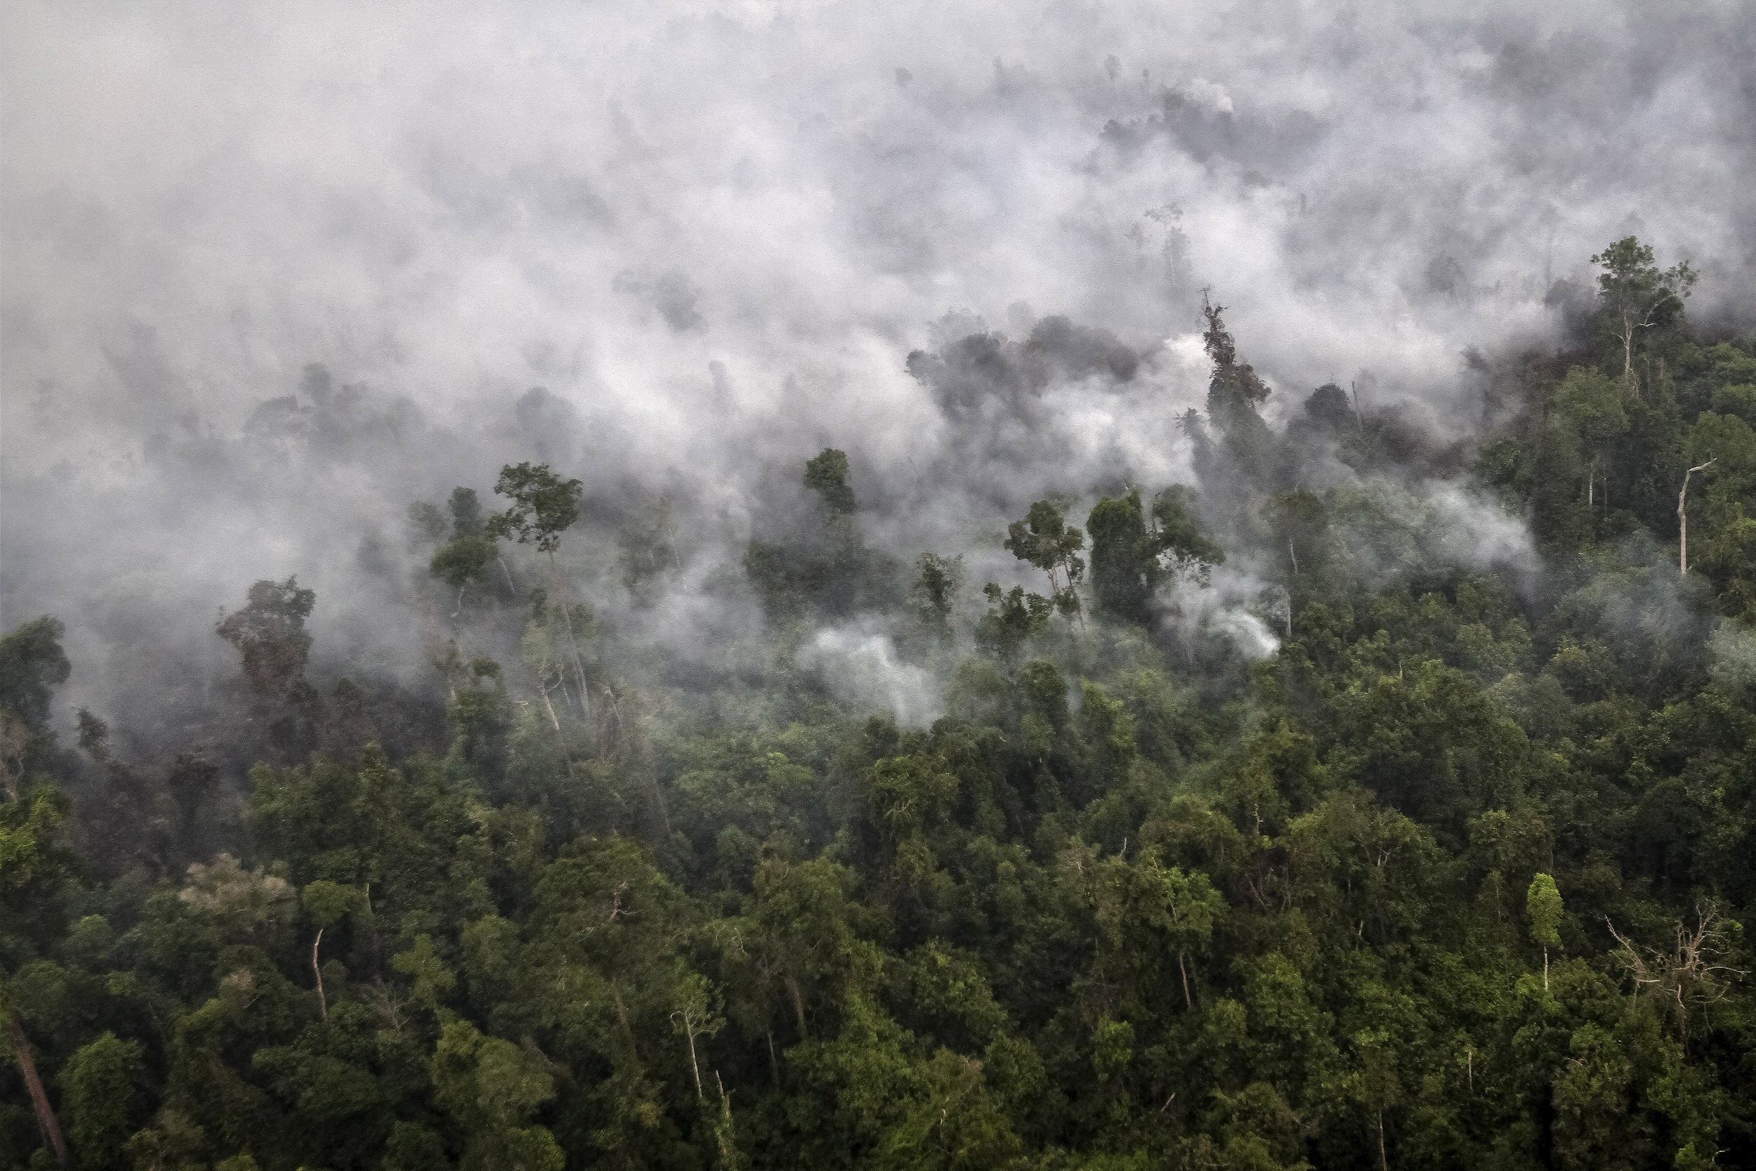

Rainforest absorb the carbon by storing it in trunks and leaves, until we burn them -> carbon bomb back into atmosphere

Intentionally fire for palm oil which is the cheapest ever. Palm oil rows as far as you can see.

Last natural place on earth with Elephant, Rhino, Tigers, Orangutan.

80% of Indonesia taken over by companies

2015 when fire it emits more carbon daily than the entire US economy

Animals are refugees; lucky survivors

People keep buying in supermarket influence, their decision affect the whole ecosystem

How to avoid ? Why aren’t governments acting against corporations ?

### 6/China

1er pollueur de la planète

First polluters of the planete

During the 35 last years, there is a massive industrialization and urbanization

They are growing. China is the world’s factory, they produce for the occidental countries

So, the biggest part of the pollution is rejected in China

Around Beijing and Sheldong peninsula only the consumption of coal equals the whole consumption of America

This is affecting the heath of the chinese population. There is a phenomen they call the air pocalpse, it is when the air toxicity is the highest, the schools are closed. You almost can’t breath when you’re outside, it can cause you throat pain.

So because of the population, you have to wear a mask.

35 dernières années => industrialisation & urbanization massive

+ expansion

chine = usine du monde

elle fabrique pour les pays occidentaux

majeure partie de la pollution rejetée en chine

au tour de beijing & sheldong peninsula consommation de charbon == toute celles des USA

affecte la santé

"air pocalypse" toxicité max, école fermé, douleur à la gorge, masque pour sortir

### 7/Deniers

Whose scientist was vilified on the editorial pages of the Wall Street Journal, on Fox News and others for publishing an article with an iconic graph on the effects of climate change known as the "hockey stick" ?

A- Dr Ampere

B- Dr Miles

C- Dr Mann

D- Dr Riley

Reponse: Dr Mann. He received threads,..fear organized : players, fossil fuel interests, folks like the Koch brothers finance a very large echo chamber of climate change denialism

"I've been the focus for attack by those who deny the reality of climate change for so long that it almost seems like forever," the professor of meteorology at Pennsylvania State University says. "I'm a reluctant public figure, but I have embraced the opportunity to communicate the science."

### 8/By cutting out beef from your alimentation you can reduce your impact on the environment by :

20%

40%

60%

**80%**



The only way to have an impact on the world without higher authority. Changing your diet.

Formost reason for deforestation is beef, inefficient use of ressource

47% land for food prod, 70% to feed for cattle, 1% for us

Methane by eating and chewing and burping

Methane = 23* CO2

10-12% of total us emissions due to beef

Can switch :

Chicken 20% of the land, 10% of emissions

Beef = 50*land of vegetables

Cutting amount of beef can be very significant

Possibility in culture ? hard, not for everyone all in

But if eliminate it then reduce 80% of what everyone emits

### 9/Carbon Tax

### 10/ Accord de Paris

When was adopted the Paris Agreement on climate change ?

-on 19 September 2013

-on 12 December 2015

-on 3 May 2016

-on 27 November 2014

Reponse: 195 states

Il a été approuvé par l'ensemble des 195 délégations le [12](https://fr.wikipedia.org/wiki/12_d%C3%A9cembre) [décembre](https://fr.wikipedia.org/wiki/D%C3%A9cembre_2015) [2015](https://fr.wikipedia.org/wiki/2015) et est entré en vigueur le [4](https://fr.wikipedia.org/wiki/4_novembre) [novembre](https://fr.wikipedia.org/wiki/Novembre_2016) [2016](https://fr.wikipedia.org/wiki/2016).

En date du 7 novembre 2017 et après ajout de la signature syrienne, 196 pays sur les 197 que compte l'[ONU](https://fr.wikipedia.org/wiki/ONU) ont signé ou se sont engagés à signer l'accord de Paris sur le climat, ce qui fait de ce texte le plus largement et le plus rapidement signé de l'histoire de l'humanité[5](https://fr.wikipedia.org/wiki/Accord_de_Paris_sur_le_climat#cite_note-5).

Oil industry

Antarctica melting

Miami floods

Desinformation

China going green: 9000 major factories. Power of media and people demonstration

India cannot go green when population has no power, so go coal

Ocean island nations contribute the less but suffer the more

Indonesia/Sumatra -> primal forest burned for palm oil

cows emits way too much

relocating for movie

Gigafactory

carbon taxe

US and China planned on changing

Paris accord : no carbon tax, no penalties, just a faith goal to be 2°C

colder golf stream so colder europe

pope call to action